**Data Flow Diagrams:**

**Simplified:**

**User Stories**

Project Design Phase-II

Data Flow Diagram & User Stories

|  |  |
| --- | --- |
| Date | 27 October 2022 |
| Team ID | PNT2022TMID40826 |
| Project Name | Project - A Novel Method For Handwritten Digit  Recognition System |
| Maximum Marks | 4 Marks |

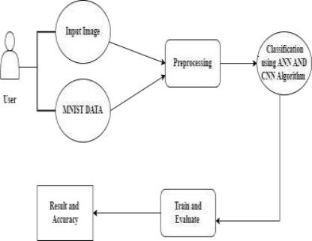

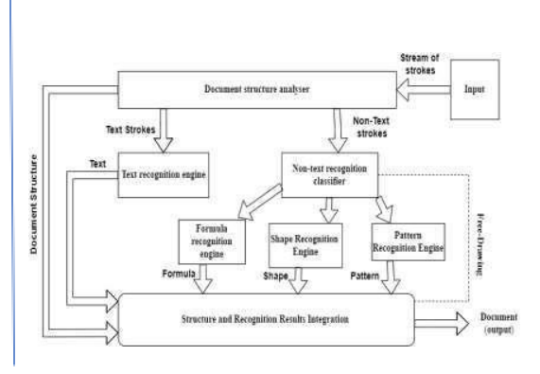

|  |  |  |  |  |  |  |
| --- | --- | --- | --- | --- | --- | --- |
| **User Type** | **Functional Requirement**  **(Epic)** | **User Story Number** | **User Story / Task** | **Acceptance criteria** | **Priority** | **Release** |
| Customer (Mobile user) | Registration | USN-1 | As a user, I can register for the application by entering my email, password, and confirming my  password. | I can access my account / dashboard | High | Sprint-1 |
|  |  | USN-2 | As a user, I will receive confirmation email once I have registered for the application | I can receive confirmation email & click confirm | High | Sprint-1 |
|  |  | USN-3 | As a user, I can register for the application  through Facebook | I can register & access  the dashboard with Facebook Login | Low | Sprint-2 |
|  |  | USN-4 | As a user, I can register for the application  through Gmail | I can register the  application with Gmail | Medium | Sprint-2 |
|  | Login | USN-5 | As a user, I can log into the application by  entering email & password | I can login to the  application | High | Sprint-1 |
|  | Home | USN-6 | As a user, I can view the application’s home page where I can read the instructions to use this application | I can read instructions also and the home page is user-friendly. | Low | Sprint-1 |
|  | Upload Image | USN-7 | As a user, I can able to input the images of digital documents to the application | As a user, I can able to input the images of digital documents to the  application | High | Sprint-3 |
|  | Predict | USN-8 | As a user I can able to get the recognised digit as output from the images of digital documents or images | I can access the recognized digits from digital document or images | High | Sprint-3 |
|  |  | USN-9 | As a user, I will train and test the input to get the maximum accuracy of output. | I can able to train and test the application until it gets maximum accuracy of the  result. | Medium | Sprint-4 |
| Customer (Web user) | Accessibility | USN-10 | As a user, I can use the web application virtually anywhere. | I can use the application in any device with a browser | Medium | Sprint-4 |